**Monkey’s Daily Routine**

7.30-9am – Breakfast/ free play

9am – Nappy time

9.30-10am – Outside play

10am – Snack time

10-11am – Free play/ creative (PE)

11am – Nappy time

11-11.30am – Yoga

11.30-12.30pm – Dinner time

12.30-2.30pm – Sleep time/ free play

2pm – Snack time

2.30-3pm – Music and movement

3pm – Nappy time

3-3.30pm – Free play/ creative (Forest field)

3.30-4.30pm – Tea time

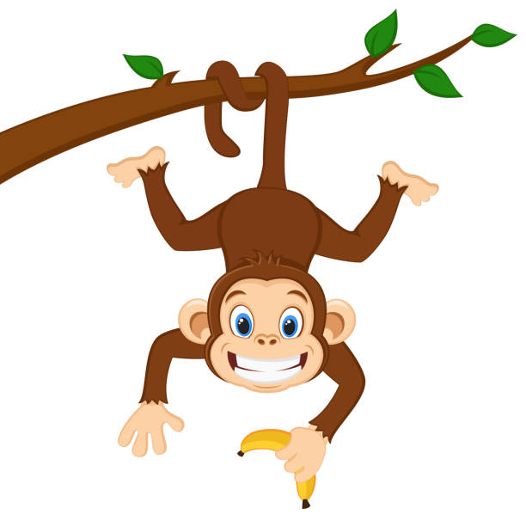4.30-6pm – Free play/ home time/ nappy checks